

DEPARTMENT OF BIOMEDICAL ENGINEERING

NOISE POLLUTION MONITORING

PHASE 5 DOCUMENT SUBMISSION

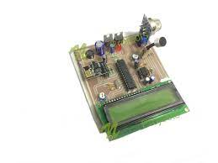

**TEAM MEMBERS:**

|  |  |
| --- | --- |
| **P.THAMARAISELVI** | 732721121056 |
| **S.SOWMIYA** | 732721121050 |
| **M.SHARMILA** | 732721121045 |
| **D.DHARSHSHINI** | 732721121012 |
| **M.MENAKA** | 732721121027 |

**NOISE POLLUTION MONITORING:**

Noise pollution monitoring refers to the systematic process of measuring, recording, and analyzing environmental noise levels in a specific area or region. This activity aims to quantify the extent and characteristics of unwanted or disruptive sounds generated by various sources, such as traffic, industrial processes, construction activities, and other human activities**.**

**OBJECTIVE:**

To systematically measure and analyze ambient noise levels in a specified area over a designated period, in order to assess compliance with established noise regulations, identify sources of excessive noise, mitigate environmental impact, and ultimately improve the overall quality of life for residents and stakeholders in the monitored area.

**PROBLEM STATEMENT:**

* Rapid urbanization and industrialization have led to a significant increase in noise pollution levels in urban areas, posing a serious threat to public health and the well-being of communities.
* Pervasive sources of noise, including traffic, industrial processes, and recreational activities,have surpassed permissible limits, resulting in chronic exposure that leads to stress, sleep disturbances, hearing impairment, and a range of associated health issues.
* Moreover, this environmental challenge extends beyond humans, affecting wildlife and disrupting ecosystems.
* Current mitigation efforts are often fragmented and insufficient to address the multifaceted nature of noise pollution. There is an urgent need for comprehensive strategies, incorporating urban planning, technological innovations, regulatory enforcement, and community engagement,to effectively curb noise pollution and create healthier, more livable urban environments

**IoT SENSOR DEPLOYMENT:**

Deploying IoT (Internet of Things) sensors in noise pollution monitoring involves the strategic placement of interconnected devices equipped with microphones or sound level meters to collect and transmit data on ambient noise levels.

Sensor Selection: Choose appropriate noise sensors that are capable of accurately measuring and recording noise levels in the desired frequency range. These sensors should also be capable of transmitting data wirelessly.

Sensor Placement: Identify strategic locations for sensor deployment. These should be representative of different noise sources and environments within the monitored area. Common locations include busy streets, industrial zones, residential areas, and recreational spaces.

Connectivity: Ensure that the selected sensors have reliable connectivity to transmit data. This can be achieved through Wi-Fi, cellular networks, or other relevant communication protocols.

Power Supply: Provide a stable power source for the sensors. This could involve using batteries, solar panels, or a combination of power sources depending on the location and accessibility.

Data Transmission and Storage: Configure the sensors to collect noise data at regular intervals. This data is then transmitted to a central server or cloud-based platform for storage and analysis.

Data Processing and Analysis: Utilize software and algorithms to process and analyze the collected noise data. This may involve filtering out background noise, identifying specific sources, and generating reports or visualizations for further evaluation.

Real-time Monitoring (Optional): Implement real-time monitoring capabilities if immediate feedback or alerts for specific noise levels are required. This can be crucial for timely response to exceedances of noise limits.

Integration with Existing Systems: Integrate the noise monitoring system with any existing environmental monitoring systems or databases for a comprehensive view of environmental conditions.

Alerts and Notifications: Set up alert mechanisms to notify relevant parties (e.g., environmental agencies, authorities, or stakeholders) when noise levels exceed predefined thresholds.

Maintenance and Calibration: Regularly maintain and calibrate the sensors to ensure accuracy and reliability of data. This includes checking for sensor drift, battery life, and any potential technical issues.

Data Accessibility and Reporting: Provide a user-friendly interface for stakeholders to access and interpret the collected data. This could include dashboards, reports, and potentially even public-facing displays for transparency.

Feedback Loop and Action Plans: Use the collected data to inform decision-making and develop action plans for noise pollution mitigation. This may involve implementing noise barriers, adjusting traffic patterns, or implementing noise-reducing technologies.

**SCHEMATIC DIAGRAM:**

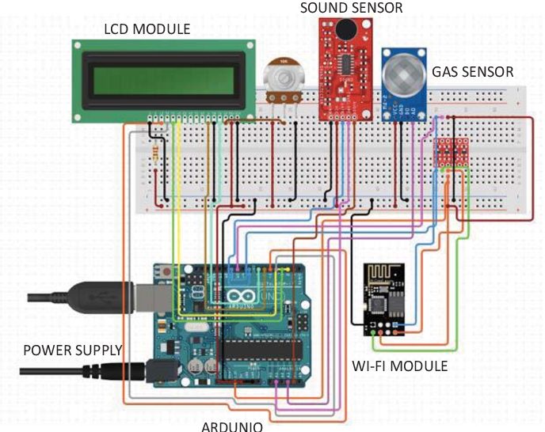

**PLATFORM FOR NOISE POLLUTION MONITORING:**

There are several platforms and technologies available for noise pollution monitoring, ranging from open-source solutions to commercial products. Here are some most commonly used platform.

Open Source Platforms:

INAD: The Internet Noise Awareness Database (INAD) is an open-source project designed for collecting, analyzing, and visualizing noise pollution data. It provides a range of tools for setting up a noise monitoring system.

Kotori: Kotori is an open-source data acquisition, logging, and visualisation platform. It can be used for various environmental monitoring applications, including noise pollution.

Commercial Platforms:

Larson Davis: Larson Davis offers a range of noise monitoring solutions including hardware and software for real-time noise measurement, data management, and reporting.

Bruel & Kjær: Bruel & Kjær provides a comprehensive suite of noise and vibration measurement solutions. Their systems cover everything from portable instruments to large-scale monitoring networks.

NoiseAware: NoiseAware is a commercial platform specifically designed for monitoring noise levels in short-term rental properties like Airbnb. It provides real-time monitoring and reporting.

Smart City Platforms:

Libelium: Libelium offers a range of IoT solutions for Smart Cities, including noise monitoring. Their platform allows for the integration of various sensors, including noise sensors, into a unified system.

Urban Observatory Platforms: Many cities around the world have established their own urban observatories that include noise monitoring as part of a larger environmental monitoring initiative. These platforms often integrate data from various sources for comprehensive analysis.

Custom-Built Solutions:

Depending on specific requirements, organizations or municipalities may opt to develop their own custom noise monitoring platforms using a combination of off-the-shelf sensors, data loggers, and software.

When choosing a platform, it's important to consider factors such as the specific needs of your monitoring project, budget constraints, data visualization and reporting capabilities, and compatibility with existing systems or IoT infrastructure.

**MOBILE APP DEVELOPMENT IN NOISE POLLUTION MONITIRING:**

Mobile app development for noise pollution monitoring involves creating a software application that allows users to interact with and contribute to a noise monitoring system using their smartphones or tablets. Here's an overview of the process:

Requirements Gathering:

Define the objectives and goals of the mobile app (e.g., real-time monitoring, historical data access, alerts, etc.).

Identify the target audience (e.g., general public, environmental agencies, researchers).

Determine the platform(s) for which the app will be developed (e.g., iOS, Android, both).

Design and User Interface (UI/UX):

Design the user interface to be intuitive, user-friendly, and visually appealing.

Create wireframes and prototypes to outline the app's structure and navigation flow.

Consider the accessibility of the app for a diverse user base.

Database and Backend Development:

Set up a database to store noise pollution data.

Develop a backend system to manage data storage, retrieval, and processing.

Implement necessary APIs for communication between the app and the server.

Integration with Sensors:

If the app interacts directly with noise sensors, integrate the necessary protocols or APIs for data transmission and reception.

Real-Time Data Handling:

If real-time monitoring is a feature, ensure that the app can receive and display data in near-real time.

User Authentication and Authorization:

Implement user authentication to secure access to sensitive data.

Define user roles and permissions to control what different types of users can do within the app.

Data Visualization and Analysis:

Develop features for visualizing noise data, such as charts, graphs, and maps.

Include options for users to filter, search, and analyze the data based on their preferences.

Alerts and Notifications:

Integrate a notification system to alert users when noise levels exceed predefined thresholds or when other relevant events occur.

Data Logging and Reporting:

Allow users to log observations or contribute additional contextual information about noise events.

Provide options for generating reports or exporting data for further analysis.

Localization and Globalization:

If applicable, consider translating the app into multiple languages and adapting it to different regional settings.

Testing and Quality Assurance:

Conduct thorough testing to identify and rectify bugs, usability issues, and performance bottlenecks.

Deployment and Distribution:

Publish the app on relevant app stores (e.g., Apple App Store, Google Play Store).

Ensure compliance with platform-specific guidelines and regulations.

Maintenance and Updates:

Regularly update the app to incorporate new features, improvements, and security patches.

Monitor user feedback and address any reported issues promptly.

User Training and Support:

Provide resources, tutorials, or support channels to help users effectively utilize the app.

**NOISE POLLUTION INFORMATION PLATFORM:**

A noise pollution information platform is a digital system designed to collect, process, analyze, and disseminate information related to noise pollution. It serves as a centralized hub for accessing data, research findings, educational resources, and tools related to noise levels and their impact on the environment and human health. Such a platform can be utilized by various stakeholders, including researchers, policymakers, environmental agencies, urban planners, and the general public. Here are key components and features of a noise pollution information platform:

Data Collection and Monitoring:

Integration with sensors and monitoring devices to collect real-time noise data from various locations.

Capability to aggregate and store historical noise data for trend analysis and research purposes.

Geospatial Visualization:

Map-based interface displaying noise levels across different regions, allowing users to explore spatial patterns.

Data Analysis and Reporting:

Tools for analyzing noise data, including statistical analysis, trend identification, and correlation studies.

Generation of reports and visualizations for easy interpretation and sharing.

Noise Source Identification:

Features to identify specific sources of noise pollution, such as traffic, industrial activities, or other anthropogenic factors.

Regulatory Compliance and Standards:

Information on local, national, and international noise regulations and standards for comparison and compliance assessment.

Alerting and Notification System:

Capability to send alerts when noise levels exceed predefined thresholds, helping authorities take timely action.

Community Engagement and Crowdsourcing:

Tools for community members to contribute their observations or noise-related concerns, providing valuable local input.

Educational Resources:

Articles, videos, infographics, and other educational materials explaining the effects of noise pollution and how to mitigate it.

Policy and Advocacy Information:

Information on policies, guidelines, and best practices for noise control and pollution reduction.

Data Export and API Integration:

Options to export data for further analysis or integration with other systems or research projects.

Multi-platform Accessibility:

Availability as a web platform and as mobile applications for widespread accessibility.

User Customization and Personalization:

Customizable dashboards, preferences, and notification settings to cater to individual user needs.

Comprehensive Search and Filtering:

Tools to easily locate specific data sets, research papers, or resources within the platform.

Feedback and User Support:

Channels for users to provide feedback, report issues, and seek assistance from platform administrators.

Privacy and Security:

Robust measures to protect user data and ensure compliance with privacy regulations.

**REAL TIME NOISE LEVEL MONITORING SYSTEM PROMOTES PUBLIC AWARENESS AND CONTRIBUTES TO NOISE POLLUTION MITIGATION:**

A real-time noise level monitoring system plays a crucial role in promoting public awareness and contributing to noise pollution mitigation in several ways:

Immediate Feedback: Real-time monitoring provides immediate feedback on current noise levels in specific locations. This empowers individuals and communities to recognize and respond to noisy situations as they occur.

Educational Tool: It serves as an educational tool by raising public awareness about the impacts of noise pollution on health, well-being, and quality of life. People can witness the variations in noise levels throughout the day and understand the sources contributing to the overall noise environment.

Community Engagement: Real-time data encourages community members to actively engage in noise pollution discussions. It allows them to contribute observations, share concerns, and advocate for noise-reducing measures in their neighborhoods.

Advocacy for Policy Change: Accessible real-time data provides evidence for advocating policy changes or implementing noise regulations. Communities can use this information to demonstrate the need for stricter noise controls, zoning regulations, or traffic management strategies.

Awareness of Quiet Zones: It helps identify and establish quiet zones or areas where noise levels need to be maintained at lower thresholds (e.g., near hospitals, schools, or residential neighborhoods).

Empowering Local Authorities: Real-time monitoring equips local authorities with the information needed to make timely decisions regarding noise abatement measures, such as adjusting traffic flow, imposing restrictions on noisy activities, or enforcing noise ordinances.

Data for Research and Studies: Continuous, real-time data collection serves as a valuable resource for researchers and environmental agencies. It supports studies on noise patterns, trends, and the effectiveness of noise reduction measures.

Accountability for Noise Sources: By providing transparent, real-time data, the system holds accountable entities responsible for generating excessive noise. This can include industries, transportation networks, or construction activities. It encourages them to adopt noise-reducing technologies and practices.

Crowdsourced Data Validation: Combining real-time data with input from the public helps validate the accuracy of measurements and identify specific noise sources that may not be immediately apparent to automated monitoring systems.

Customized Alerts and Notifications: Real-time systems can be equipped with alerting features to notify relevant parties (e.g., authorities, residents) when noise levels exceed specified thresholds. This ensures timely response to potentially harmful noise events.

Behavioral Change: Knowing that their noise levels are being monitored in real time can encourage individuals and businesses to adopt quieter practices and technologies, contributing to a reduction in overall noise pollution.

Public Health and Well-being: Reduced noise pollution positively impacts public health by lowering stress levels, improving sleep quality, and reducing the risk of related health issues.

**PROGRAM:**

#include &lt;Wire.h&gt;

#include &lt;Adafruit_Sensor.h&gt;

#include &lt;Adafruit_BME280.h&gt;

#include &lt;SoftwareSerial.h&gt;

SoftwareSerial mySerial(2, 3); // RX, TX

Adafruit_BME280 bme;

void setup() {

Serial.begin(9600);

mySerial.begin(9600);

if (!bme.begin(0x76)) {

Serial.println(&quot;Could not find a valid BME280 sensor, check wiring!&quot;);

while (1);

}

}

void loop() {

delay(2000);

float temperature = bme.readTemperature();

float humidity = bme.readHumidity();

float pressure = bme.readPressure() / 100.0F;

float noise_level = calculateNoiseLevel();

mySerial.print(temperature);

mySerial.print(&quot;,&quot;);

mySerial.print(humidity);

mySerial.print(&quot;,&quot;);

mySerial.print(pressure);

mySerial.print(&quot;,&quot;);

mySerial.println(noise_level);

}

float calculateNoiseLevel() {

return 75.0;

}

**OUTPUT:**

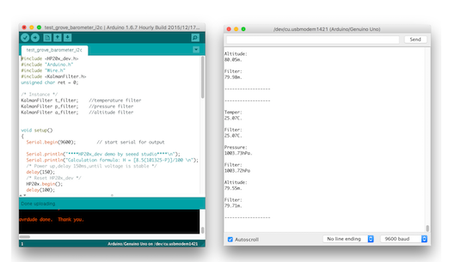

**CONCLUSION:**

Unwanted sound (noise) can damage physiological health. Noise pollution can cause hypertension, high stress levels, tinnitus, hearing loss, sleep disturbances, and other harmful and disturbing effects. Noise is any disturbing or unwanted sound, and noise pollution affects people's health and quality of life.